CONSENT

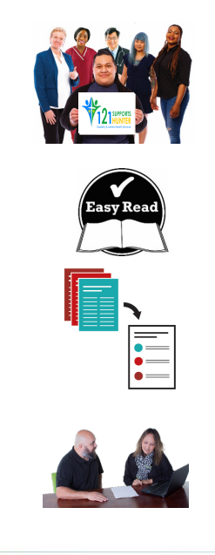
When you see the words ‘we’ or ‘us’, it
means Quality Health Care (QHC).

We have written this document in an easy-to-read way. We use pictures to explain some ideas.

This Easy Read document is a summary of other QHC documents. It reflects some of the policies that we have in place and NDIS Practice Standards that we follow.

You can ask for help to read this document. A friend, family member or support person may be able to help you.

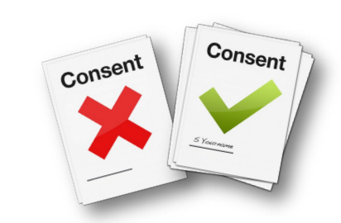
WHAT IS A CONSENT FORM?
Consent is when you let us know if you agree for us to disclose and share your information.

HOW DO I USE THIS CONSENT FORM?
Someone from QHC must show you the form.
They will explain it to you and help you fill it out.

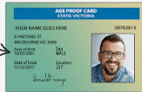
Is it ok for us to collect information with your details in it?
Like your name, date of birth or medical history.

Like Reports about you.

Is it okay if we talk to other people about how we can give you the best support?
We will make sure you are part of this.

Is it okay to share information with your family?

Staff will explain how your choice will help you
Staff will explain that you can change your mind about anything in this form at any time.

We may share your information with other services and government organizations.
We do this to support you in the best way.

We may share your information with your doctor, nurses, physiotherapist, speech therapist, ambulance service, social worker, dietitian and other medical and allied health professionals

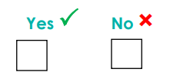

SIGNATURE PAGE
This is where staff sign Date
--------------------------------------- --------------------------------------------------
Staff write their full name in clear letters. For example, ‘John Smith’.

This is where you sign: Date
---------------------------------------- --------------------------------------------------
Write your full name in clear letters. For example, ‘John Smith’.

If your guardian answered the question:
This is where guardians sign Date
---------------------------------------- ---------------------------------------------------
Your guardian writes how they know you. For example, they might be your sister.
-----------------------------------------------------------------------------------------------------

