

**KEEPING YOU SAFE**

When you see the words ‘we’ or ‘us’, it

means Quality Health Care (QHC).

We have written this document in an easy-to-read way. We use pictures to explain some ideas.

This Easy Read document is a summary of other QHC documents. It reflects some of the policies that we have in place and NDIS Practice Standards that we follow.

You can ask for help to read this document. A friend, family member or support person may be able to help you.

**WHAT IS MEAN?**

We have Zero tolerance to **MEAN.**   
MEAN is never okay.

MEAN is mistreatment Exploitation, Abuse, Neglect and Discrimination.

MEAN is when someone treats you badly or unfairly

MEAN is when someone does not respect your human rights

**Mistreatment**This is never okay

**Mistreatment** is when someone treats you badly or is cruel to you

It is like:

Someone bullying you



Someone making fun of you

Someone not letting you do what you want

**Exploitation**    
This is never okay

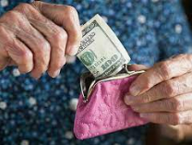

Exploitation is when someone takes advantage of you.

Exploitation is when someone takes your money without you knowing.

Exploitation is when someone uses your photo without you saying it is okay.

**Abuse**This is never okay.

Abuse is like when someone hurts you or treats you badly.

Abuse is like when someone touches you where you do not want to be touched.

Abuse can be verbal, physical, emotional, or sexual.

**Neglect**   
This is never okay.

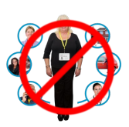

Neglect is when someone does not give you the care or help you need

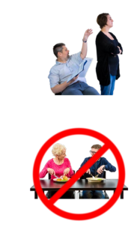

Neglect is when someone is ignoring you.

Neglect is when someone does not give you enough food.

**Discrimination**   
This is never okay.



Discrimination is when someone treats you unfairly because of things that you cannot change like:

Living with a disability.

Your age, race, religion, sex, sexuality, or relationship status.

Discrimination is against the law.

QHC staff respect you and will not discriminate  
 against you.

We will support you if you are discriminated against

by someone else.   
  
  
  
  
  
We can talk about what to do if something is bad and what you can do to stop it.

**WHAT DO I DO IF SOMEONE IS MEAN TO ME?**

If someone is mean to you it is your right to tell someone.

You should tell someone you trust like a friend, family, or Quality Health Care staff.

You can call 000 and tell the police.

You can make a complaint.

**WHAT HAPPENS AFTER I TELL SOMEONE?**

Everyone at Quality Health Care must follow these steps right away.

1. Make sure you and everyone around you is safe.

2. Call 000 in an emergency.

3. Get medical help for anyone who needs it.

4. Tell their manager.

5. Keep your details private and only tell people who need to know.

**WHAT WILL THE MANAGER DO?**

1. Your manager will make sure things have been done right.

1. Your manager will ask everyone involved if they want to talk to someone about it.

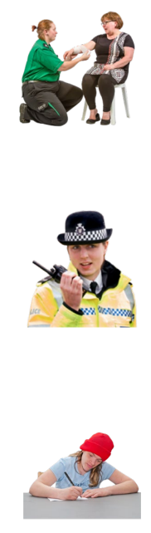

5. Your manager will make sure everything is written down and kept safe.

4. Your manager may call the police if the law has been broken.

3. Your manager will make sure that you do not have to be near the person who treated you badly.

Quality Health Care will make sure you are always safe.

7. There will be an investigation

Quality Health Care will write a report so you will not be treated badly again.

6. Your manager will help you contact an advocate.   
  
An advocate is someone you can trust.   
An advocate can help you to know about your rights and support you.