COMPLAINTS, FEEDBACK AND MORE SUPPORT

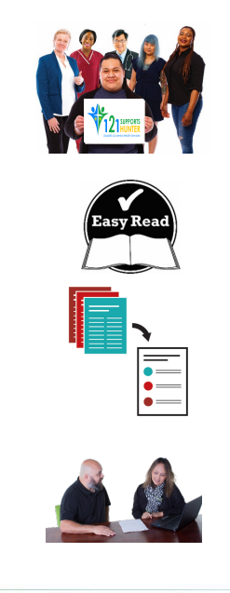

When you see the words ‘we’ or ‘us’, it
means Quality Health Care (QHC).

We have written this document in an easy-to-read way. We use pictures to explain some ideas.

This Easy Read document is a summary of other QHC documents. It reflects some of the policies that we have in place and NDIS Practice Standards that we follow.

You can ask for help to read this document. A friend, family member or support person may be able to help you.

WHAT DO YOU DO IF YOU HAVE A COMPLAINT OR FEEDBACK?
You can tell us about your complaint or feedback.
You can do this by:
Email: Office@qualityhealthcare.com.au
Phone: 02 959 8600
Or in person by talking to a manager or a staff member
If you would like further help, outside Quality Health Care we have created this document to help you.

WHY WE HAVE THIS DOCUMENT?
WHERE DO YOU GO FOR MORE SUPPORT?
This document is about contact options for further support, to make complaints or to leave feedback.
It is our policy that we represent our clients with contacts that may be useful to them.

There are agencies and groups who can help

If you are deaf or have trouble speaking you can ring the National Relay Service on 133 677

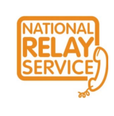

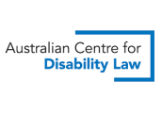
You can call 1800 800 708 or
TTY 1800 644 419

Australian Centre for Disability Law (ACDL)

You can visit their website at www.disabilitylaw.org.au

National Association of Community Legal Centres (CLC)

You can call 02 9264 9595
You can visit their website at
www.naclc.org.au

Trpile Zero Service for emergencies only
You can call 000
or text 106 if you are deaf
You can visit their website at
www.triplezero.gov.au

National Sexual Assault, Domestic Family Violence Counselling Service
You can ring 1800 737 732
You can visit their website
www.1800respect.org.au

Aboriginal Legal Rights Service – ALS
You can call 1800 733 233
You can visit their website at
www.alsnswact.org.au

Relationships Australia
You can call 1300 364 277
You can visit their website at
www.relationships.org.au

New South WalesCivil and Administrative Tribunal (NCAT)
You can call 1300 006 228
You can visit their website at
www.ncat.nsw.gov.au
You can visit their website at
www.lawaccess.nsw.gov.au
Law Access NSW
If you need Legal help
You can call 1300 888 529

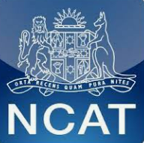

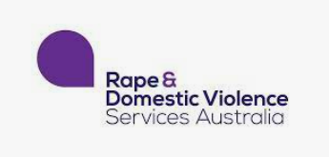
NSW Rape Crisis
You can call 1800 424 017
You can visit their website at
www.rape-dvservices.org.au

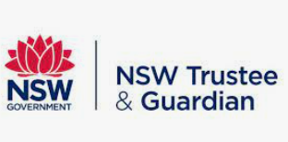
NSW Trustee and Guardian
You can call 1300 364 103
or TTY 1800 882 889
You can visit their website at
www.tag.nsw.gov.au

