YOUR RIGHTS

WHAT DO YOU KNOW ABOUT YOUR RIGHTS?

When you see the words ‘we’ or ‘us’, it
means Quality Health Care (QHC).

We have written this document in an easy-to-read way. We use pictures to explain some ideas.

This Easy Read document is a summary of other QHC documents. It reflects some of the policies that we have in place and NDIS Practice Standards that we follow.

You can ask for help to read this document. A friend, family member or support person may be able to help you.

WHY WE HAVE THIS POLICY?
This document is about YOUR rights
Our policies need to respect the rights of people with disability.
You should be included in community life.
You have the same rights as everyone.
WHAT ARE YOUR RIGHTS?
You Should Be Able To:
Make your own choices and have control over your own supports that you choose.
Receive good services.
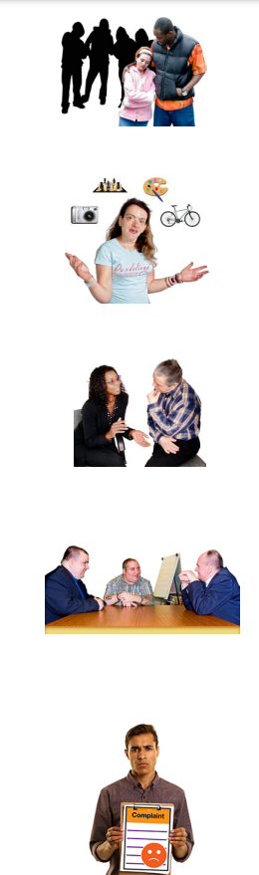
Be safe – no one is allowed to hurt you.
Try new things and take risks sometimes.
If you want, you can seek support from other people – such as your family, or an advocate.
Work with other services if that’s what you need to reach your goals.
If you are unsatisfied with any of the services, make complaints.
OUR SERVICES SHOULD:
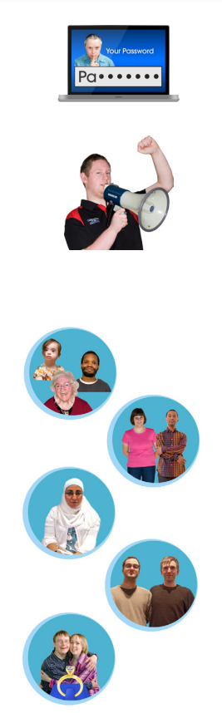
Respect everything about you when you are making choices and decisions including:
- Your age
- Whether you are a man or woman
- Your cultural background, religion or faith
- Your sexuality
- Whether or not you are married
Let you speak up.
Respect your privacy.
CONTACT US
YOU CAN ALSO TELL
NDIS Quality Safeguards Commission
contact@ndiscommission.gov.au
1800 035 544 (free call from landlines)
or TTY 133 677
If you are discriminated against or bullied
Australian Human Rights Commission
1300 369 711
www.qualityhealthcare.com.au
3-5 Forest Rd Hurstville, NSW 2221
Office@qualityhealthcare.com.au
QHC Office: 02 9598 6000

