

**WHISTLEBLOWING**

When you see the words ‘we’ or ‘us’, it

means Quality Health Care (QHC).

We have written this document in an easy-to-read way. We use pictures to explain some ideas.

This Easy Read document is a summary of other QHC documents. It reflects some of the policies that we have in place and NDIS Practice Standards that we follow.

You can ask for help to read this document. A friend, family member or support person may be able to help you.

**WHAT IS WHISTLEBLOWING?**

It is when you tell someone about people doing things that are not allowed.

It is when you tell someone who should do something about it. For example, a boss.

You should not feel afraid to tell

someone in charge.   
 They will listen to you.

**WHAT IS NOT ALLOWED**

Being mean to other people

Not respecting your rights

Not following the rules

Stealing

**\WHAT DO WE THINK OF WHISTLEBLOWING?**



We want people to whistle blow.

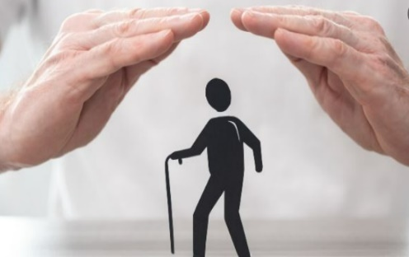

It helps us be excellent in protecting you.

No one is allowed to treat you badly because you whistleblow.

QHC will protect people who whistleblow.

**HOW CAN I WHISTLEBLOW?**

You can tell your Team Leader or a boss at QHC.

You can tell a group called **Your Call**

They are a group that listens to people who whistleblow.

You can call them on **1300 790 228**  
after 9 O’clock in the morning and fore 12 midnight   
Monday to Friday

You can email them at   
**info@yourcall.com.au**

Your Call will tell QHC about what you said.

Your Call will not say your name if you do not want them to.

If you are **deaf** or **have trouble speaking**  
you can call the **National Relay Service**

Call National Relay Service on 133 677

Visit their website at [www.communications.gov.au](http://www.communications.gov.au)

**WHO DO I CALL IF I HAVE OTHER CONCERNS ABOUT MY SERVICES?**

**The National Disability Insurance Agency - NDIA**

You can call them on **1800 800 110**

**The Complaints Resolution and Referral Service**

You can call them on **1800 880 052**

**The National Disability Abuse and Neglect Hotline**

You can call them on **1800 880 052**

**Both options are part of Job Access**

If someone is breaking the law,   
call the **Police on 000**